Experiment-7

***Steady-state performance of a 1-phase transformer***

***Objective:***

Obtain equivalent circuit parameters by conducting open-circuit, short-circuit and resistance measurement tests.

***Theory:***

A single-phase transformer essentially consists of two magnetically coupled windings capable of transforming the voltage and current level of the alternating supply to different values. The two windings, one called the input or the primary winding and the other called the output, or the secondary winding are placed on the same core made of silicon steel stampings. The core provides a low reluctance path for the alternating magnetic flux, which links both the windings.

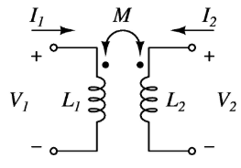

If we assume the pulsating flux Ф to have a sinusoidal waveform Фm cos ωt, where ω is the supply frequency in radians per second, the induced primary voltage is given by

E1 = -N1dФm/dt …. (1.1)

where N1 is the number of primary turns.

Thus, the primary RMS induced voltage E1 is proportional to the primary turns N1 and lags behind the flux by 90º. Since the flux Фm also links with the secondary turns and is in phase with E1.

E1/E2 = N1/N2 ……(1.2)

Now, E1 opposes the applied voltage say VI and is nearly equal to VI if the primary resistance and leakage reactance are very small. Figures 1.1 and 1.2, 1.3 and 1.4 respectively show the equivalent circuit and phasor diagram of a single-phase transformer.

Now with the primary resistance and leakage inductance neglected, we have

E1 = V1 ……(1.3)

E2 = V2 …..(1.4)

Since E2/E1 = N2/N1, we can say that V2/V1 = N2/N1. Thus, approximately the output voltage bears the same ratio to the input voltage, which secondary turns bear to the primary turns.

So far the secondary has been considered open circuited. If it is loaded, a current I2 will flow through the load and secondary winding. The effect of this current is to reduce the flux Фm according to Lenz’s law. This decreases the induced emf E1. The current now rushes from the primary supply to cancel the effect of the secondary current and to establish equilibrium flux Фm. Thus, the power has been transferred from the primary to the secondary winding through the mutual flux. Now ignoring the losses, one can say that output power is equal to the input power. Thus

I2E2 = I1E1

I2/I1 = E1/E2 = N1/N2 …..(1.5) Therefore the current ratio is equal to the inverse of the voltage turns ratio. This situation in the phasor diagram where I2’ is shown to balance the effect of I2 and the total input current on load become I1. The phasor diagram can now be modified to include the effect of resistance and leakage reactance of the windings.

It is well known that the equivalent circuit of a single-phase transformer can be approximately represented as shown in Fig.1.2. The parameters R0 and X0, which take into account the two components of no-load current, can be determined by conducting the OPEN-CIRCUIT test. The parameter R1 and X1 are determined by SHORT-CIRCUIT test. These parameters depend to a certain extent on the actual load conditions of the transformer.

***Equipment and Components***

(a) One 1-ϕ transformer of same ratings.

(b) One 1-ϕ auto-transformer.

(c) One low pf watt meter.

(d) One A.C. ammeter.

(e) One A.C. voltmeter.

***Procedure, Connection Diagrams, Experimentation and Precautions*** Note down the nameplate details of the transformer and identify terminals. Observe the windings and constructional features.

OPEN-CIRCUIT Test

The open circuit test is usually done on the LOW-VOLTAGE side, keeping the HIGH-VOLTAGE side open. Make connections as shown in Fig. 1.5. Apply rated voltage V0 and note the corresponding power input (W0) and current drawn (I0). Repeat the above for different input voltages and tabulate the readings as shown in Table.1.1.

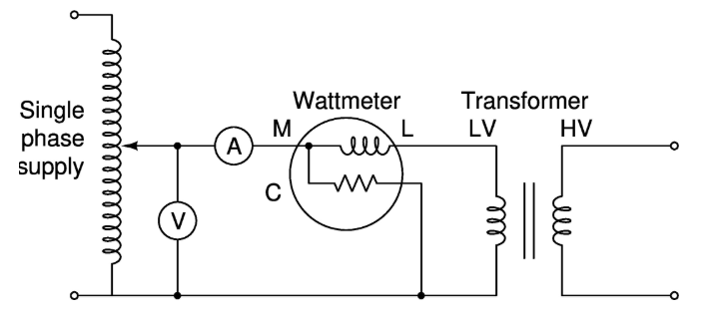

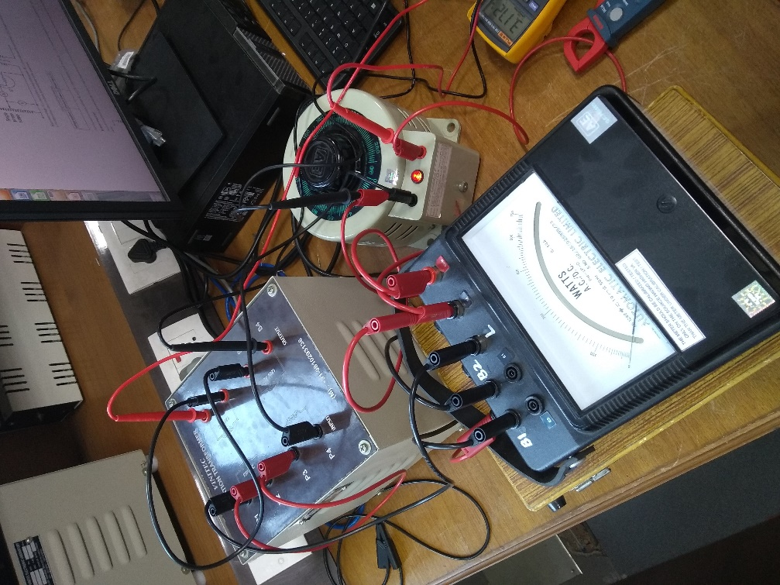

Snapshot of the breadboard with the circuit connected as in Fig. 1.5 in manual

SHORT-CIRCUIT Test

The short circuit test is usually done on the HIGH-VOLTAGE side, keeping the LOW-VOLTAGE side short-circuited. Make connections as shown in Fig.1.5. Apply the required voltage (VSC) so that the current drawn (ISC) is equal to the rated current. Note the corresponding power input (WSC). Repeat the above for different values of short-circuit currents and tabulate the readings as in Table.1.2.

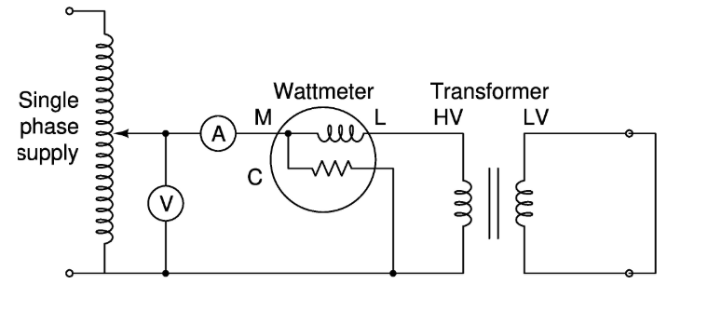

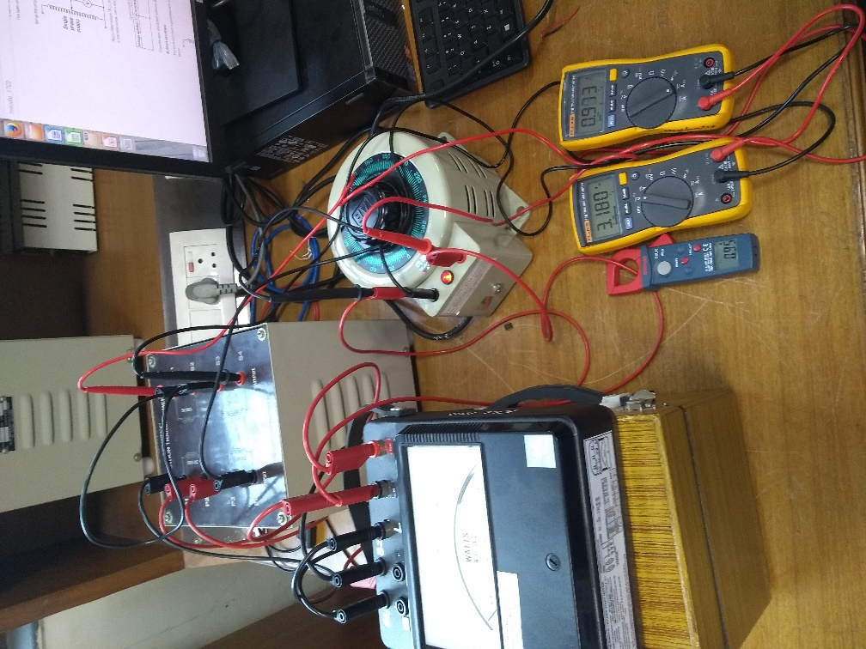

Snapshot of the breadboard with the circuit connected as in Fig. 1.6 in manual

***Observation******Table:***

OPEN-CIRCUIT TEST:

|  |  |  |  |  |
| --- | --- | --- | --- | --- |
| S.No. | Primary Voltage (V) | Primary Current (A) | Input Power (W) | Secondary Voltage (V) |
| 1 | 46.79 | 0.02 | 2.2 | 46.29 |
| 2 | 92 | 0.04 | 5.6 | 92 |
| 3 | 138.3 | 0.07 | 10.6 | 138.3 |
| 4 | 184 | 0.1 | 17.2 | 184.2 |
| 5 | 230.3 | 0.15 | 24.7 | 230.5 |

SHORT-CIRCUIT TEST:

|  |  |  |  |  |
| --- | --- | --- | --- | --- |
| S.No. | Primary Voltage (V) | Primary Current (A) | Input Power (W) | Secondary Current (A) |
| 1 | 12.65 | 4.96 | 53 | 4.94 |
| 2 | 9.17 | 3.5 | 29 | 3.48 |
| 3 | 6.19 | 2.28 | 13 | 2.29 |
| 4 | 3.18 | 0.99 | 5 | 1.01 |

Determination of the Coefficient of Coupling

Measure the resistance of primary winding (R1) and secondary winding (R2) by using a low voltage/ battery supply. Conduct OPEN-CIRCUIT test on the primary side (for rated voltage) with a voltmeter connected to the secondary side. Note the OPEN-CIRCUIT input voltage (V10), input current (I10), and the secondary induced voltage (E20) and tabulate the readings as shown in Table.1.3. Now, short circuit the secondary windings and supply the required voltage on the primary side so that the short-circuit current is equal to the rated current. Note the corresponding voltage (V1SC) and current (I1SC) and tabulate as shown in Table.1.3.

Equivalent Circuit Parameters

The four parameters of the equivalent circuit are R0, X0, R1 and X1 (see Fig.1.1). R0 and X0 are obtained from OPEN-CIRCUIT test, and R1 and X1 are obtained from the SHORT-CIRCUIT test as follows:

Calculation

**For OPEN-CIRCUIT test,**

No load P.F. (cos ϕ0) = W0/V0I0 = 24.7/(230.3*0.15) = 0.715

∴ sin ϕ0 = 0.699

IW= I0 cos ϕ0= 0.15 * 0.715 = 0.10725 A

Iµ = I0 sin ϕ0= 0.15 * 0.699 = 0.10485 A

R0 =V0/IW = 230.3/0.10725 = 2147.32 Ω

X0 = V0/Iµ = 230.3/0.10485 = 2196.47 Ω

**For SHORT-CIRCUIT test,**

Total impedance referred to HIGH-VOLTAGE side (sec. side),

ZSC = VSC/ISC = 12.65/4.96 = 2.55 Ω

Total resistance referred to HIGH-VOLTAGE

RSC = WSC/ISC2 = 53/4.962 = 2.15 Ω

∴ XSC = sqrt(ZSC2 – RSC2) = sqrt(2.552 – 2.152) = 1.37 Ω

∴ Total resistance referred to LOW-VOLTAGE side (primary),

R1 = R2 (N1/N2)2 = R2  {N1/N2 = 1}

∴ R1 = R2 = RSC/2 = 1.075 Ω

Similarly,

X1 = X2 (N1/N2)2 = X2 {N1/N2 = 1}

∴ X1 = X2 = XSC/2 = 0.685 Ω

Coefficient of Coupling (K)

K = M/sqrt(L1L2) = X0/sqrt((X1+X0)(X2+X0)) = 0.999688

***Conclusion:***

From the above experiment, we have been able to calculate the various circuit parameters of a real transformer using the open-circuit and short-circuit tests. Through this experiment, we were introduced to the single-phase transformer circuit and its operations. This helped me to know the actual working of a transformer and its underlying principle. The various types of losses (flux loss, iron loss) hint the deviation from expected results.

Thus, this lab report contains the theory, observations and calculations of various circuit parameters of a single-phase transformer.

The various circuit parameters are

cos ɸ = 0.715

Iw = 0.10725 A

Iµ = 0.10485 A

Ro = 2147.32 Ω

Xo = 2196.47 Ω

ZSC = 2.55 Ω

RSC = 2.15 Ω

XSC = 1.37 Ω

R1 = R2 = 1.075 Ω

X1 = X2 = 0.685 Ω